Title

installation of Genesys

Prepared By
Team Lead

Date: 08-Oct-2018
Version 2.0

Document History

Document History

Date | Author | Revision | Description
26-10-2010 | Team Lead Helpdesk | 1.0 | Document Creation
08-10-2018 | Team Lead Helpdesk | 2.0 | Company Name changed from TBSS to CBSL

Approved By: | Conneqt Business Solutions Limited
Manager-Technology | 2.0

Distribution List
Name | Department | Company | Rights
Manager-IT Support | Technology | CBSL | Review & Comment
Manager-Technology | Technology | CBSL | Modify
AVP Technology | Technology | CBSL | Review & Approve

Security Classification: CBSLRestricted.

Genesys installation procedure
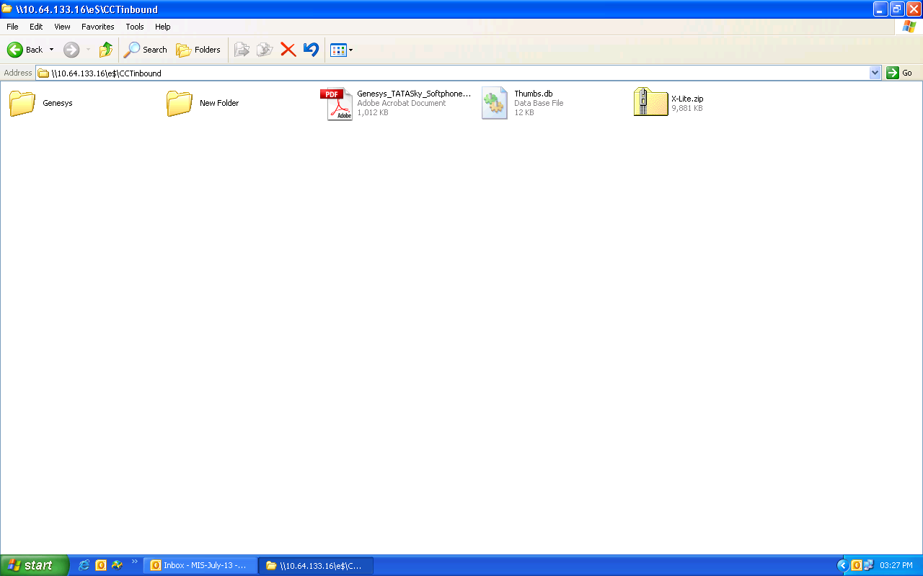
\\10.64.133.16\e$\CCTinbound select genesys folder

Inside genesys folder
\\10.64.133.16\e$\CCTinbound\Genesys --> InteractionWorkspace -->Windows-->Setup.exe (run this setup file)

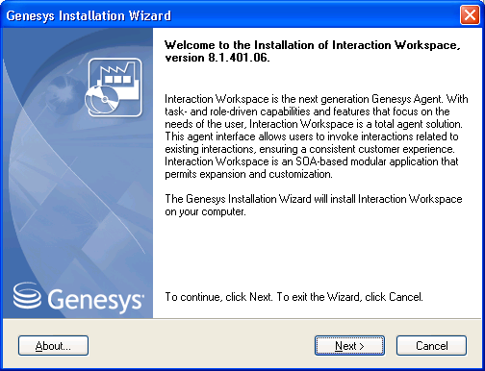

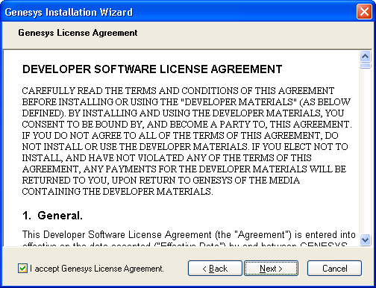
Select the last option of “Install Interaction Workspace Application”
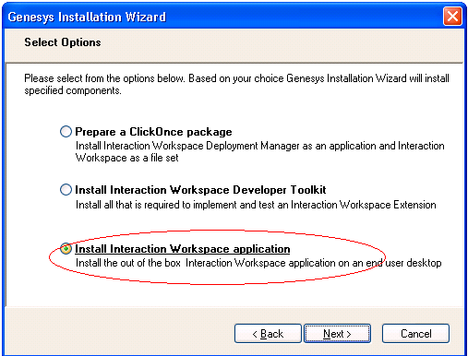

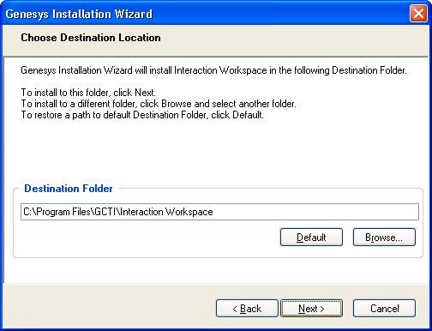

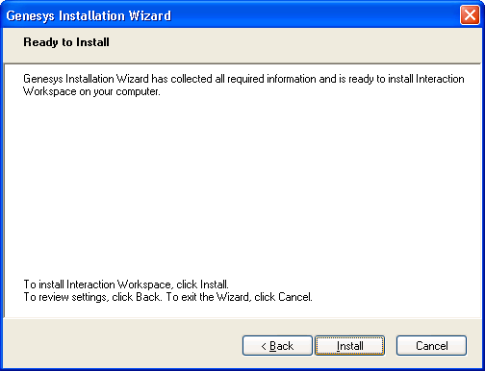

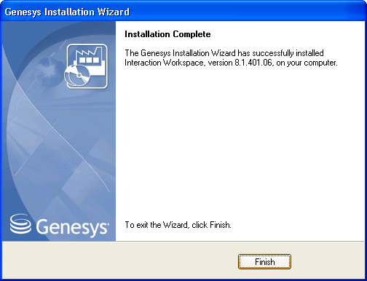
After this installation finished go to the below path and install the second setup file
Path
\\10.64.133.16\e$\CCTinbound\Genesys\ -SIP_END POINT\Windows - setup.exe
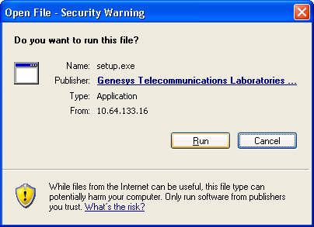

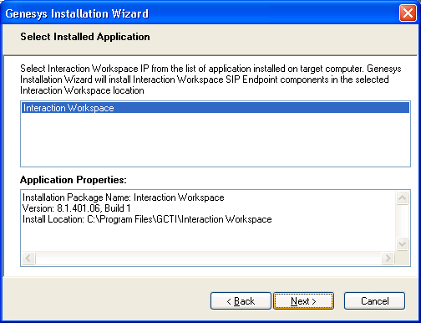

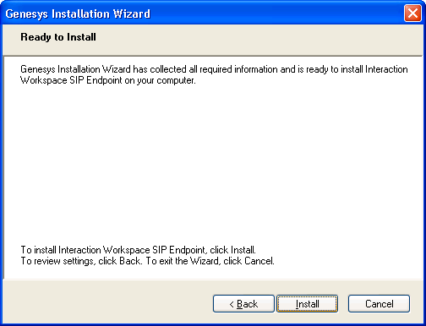

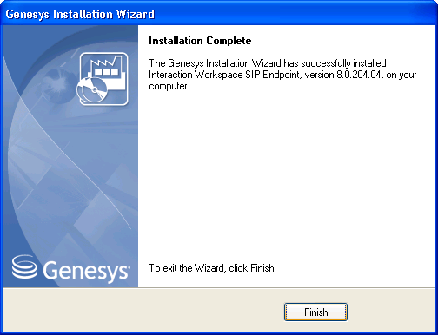

After installation finished replace the config file in the below mentioned path (take the config file from the below mentioned path)
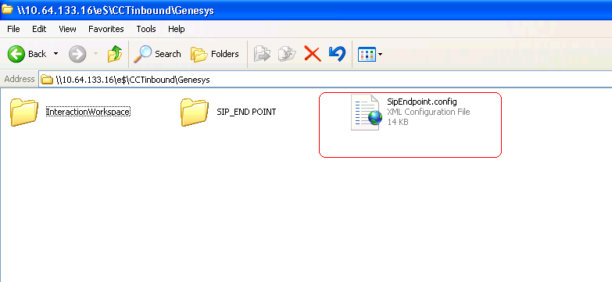

Copy the above shown .config file and replace it in the below path where you are installed the above 2 setup files

C:\Program Files\GCTI\Interaction Workspace\InteractionWorkspaceSIPEndpoint

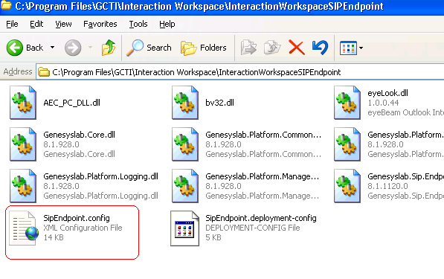Replace the .config file as shown below.
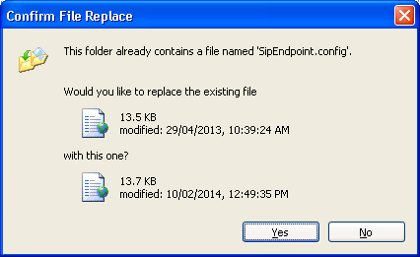

Thank you

